**Effects of Incoterms, Taxes, and Flags of Convenience to Global Supply Chains**

Marco Nunez Moctezuma1, Brandon Ledesma1, Bhagyashri Patil2

1: Management Information Systems, San Diego State University, USA

2: Big Data Analytics, San Diego State University, USA

**Abstract**

Blanco et al. in their 2015 paper, *Modelling the Impact of Trade Facilitation in Global Supply Chains* sought to establish “high resolution models that allow measuring the impact of trade facilitation policies in supply chain operations.” The purpose of this paper is to update the model Blanco et al. developed by examining the impacts caused by the changes in the 2020 revision to Incoterms and the passing of the American Tax Cuts and Jobs Act of 2017. There are some minimal changes in the results that the proposed model showed when compared to the results received by Blanco et at. The proposal to incorporate the choice of flag flown by ships into the equation is also implemented into the model.

Keywords: Cost modelling, international logistics, Incoterms, Tax Cuts and Jobs Act, Maritime Flags

# Introduction

Blanco et. al’s paper set out to try to model the cost of a supply chain from the point of inception to the point of receipt by the customer. Needless to say, there are a lot of components of this such as tier 2, tier 3, and so on suppliers, but also less subtle variables like the choice of Incoterms to reference or the pay terms used. Many models had existed before which Blacno et al. referenced in their paper, but Blanco et al. sought to further refine the model and add missing variables like those previously mentioned. Once their model was drafted, they attempted to use it to identify possible improvements to the Columbian logistics ecosystem. This yielded a number of insights, however those insights were all at the macro level. The intended results of this paper is to update the model and apply it at a micro level.

As a second point of focus, tax policy impacts global supply chains by reworking companies’ business models and revenue streams. Tax Cuts and Jobs Act (TCJA) changes can cause base erosion and profit shifting (BEPS) to occur. Companies decide to move operations onshore or offshore in order to adapt their corporate tax planning strategy to government policy changes. For instance, onshoring to the US could result in a tax rate of 13.125% stated in the foreign-derived intangible income (FDII) (Zaiken 2019). FDII rules apply to onshoring, while global intangible low-taxed income (GILTI) rules apply to offshoring. In order to analyse the effects of FDII and GILDI rules, the supply chain’s performance must be modelled using the company’s facilities, inventory, transportation, and data on their systems.

Finally, the third point of focus is to seek to understand how the choice of flag that a logistics carrier flies affects the model. The company of choice, Acesco, will support the exploration of this concept.

# Literature Review

*1 Flags of Convenience*

According to Forbes, 70% of all ships are registered in 6 nations, with 50% being registered in just three: Panama, Liberia, and the Marshall Islands. Panama registers the most ships at 22% (Republic of Panama Ministry of External Relations). This is significant enough that their government website’s page about flags of convenience is in English while the main site is in Spanish.

William Gregory in his thesis on flags of convenience explains what flags of convenience are:

The term flag of convenience, as noted in the introduction, is a customary layman’s term for a vessel’s flag when registered in an open registry. Open registries are countries typically “not involved in waterborne trade” that become maritime registers for vessels simply as a source of revenue. (Gregory 2)

Gregory goes on to comment that:

Flags of convenience (are) a tool developed by the modern maritime business to

circumvent Western labor and tax regulations through international vessel

registration, pose a significant risk to the well-being of global seafarer labor and

contribute to the decline in prominence of American Merchant Mariners. When an

American-owned vessel is outsourced via a flag of convenience, the owner is no

longer required to follow American labor laws or pay American taxes, and this

motivation is one of the most frequent reasons for the action. (Gregory ii)

This is not an isolated opinion. All sources who comment on the purpose of a flag of convenience usually cite cost saving measures as the key purpose. As Gregory notes, one of the main purposes is to “escape U.S. regulation and strong seafaring unions” and select countries with “weak to nonexistent” laws on the books. (Gregory 3) Effectively rendering national laws unenforceable aboard the ship has great advantages for the cost-driven owner: he can “circumvent the labour and maritime laws” of his home state, while enjoying all of the benefits of operating from his home office (such as access to capital).” (Gregory 40)

Other reasons a shipowner might choose a flag of convenience are restricted carbotage on ship registration (access to trade with certain restricted countries), better flag administration, better flag reputation, lower administrative costs, meet certain insurance requirements, and naval protection that is derived from flying a certain flag (Govindasamy 2018). Per a study by the U.S. Department of Transportation Maritime Administration, U.S.-flag wages are significantly higher than foreign-flag wages for a variety of reasons such as the U.S having a higher standard of living and other social benefits along with restrictions on the number of hours a given employee can work. These factors contribute approximately $12,000 to $15,000 per day to total U.S.-flag operating costs (U.S. Department of Transportation 5-6).

Registering with Panama in particular is very easy. Per the Consulate General of Panama in Marseille:

The procedure to register ships with the Panamanian flag is very simple and expeditious. The request for provisional registration can be made through the Consulate General of Panama in Marseille…We must clarify that at the Consulate General of Panama in Marseille, we do not request any Administrative Costs neither Consular Fees nor the payment to third parties. Our customers pay only the amount stated in the official account statement provided directly by the Panama Maritime Authority, which guarantees security and transparency.

Once all the documents have been received and the rights have been paid, a provisional patent will be issued, which has a duration of six months, while the provisional radio licence has a duration of three months. The whole procedure takes about 6 hours to complete.

While the drive to cut costs is not unique to ship freight, neither are the risks that come with reducing costs. The Deep Water Horizon oil rig, noted for its aversion to risk mitigation, was registered under the flag of the Marshall Islands (Clark 2010). Marshall Islands, being such a small nation but one of the top six countries for flags of convenience as noted by Forbes, clearly does not have the resources to through manage all of their flagged ships. One may think that lower maintenance requirements would lead to lower costs, but the U.S. Department of Transportation in their study found that the opposite is true, noting that “owners who actively engage in preventative maintenance may incur lower lifecycle costs relative to vessels that are properly maintained”. Flags of convenience, much like any other project, comes down to cost versus risk mitigation and a prospective ship owner must carefully weigh the risk vs cost savings of any flag they select.

*2 Tax Policies and Global Supply Chains*

Trade policies, particularly in regards to tax, can have a domino effect on how businesses participate with each other. For instance, the United States implemented the Tax Cuts and Jobs Act in 2017 from which the United States government attempted to retain corporate investments by distributing large tax cuts. Prior to the act, the United States lost more than $100 billion a year from corporate profit shifting (Clausing 2020). Moreover, in 2002 the United States imposed tariffs on steel, which after one year cost 200,000 American jobs compared to the 187,500 American jobs in the steel industry (York 2018). Even though governments are often seen as individual entities, when global trade is involved, the governments are interconnected by multiple trade flows (Chen 2022). Tariffs tend to distribute the collateral impacts throughout the global supply chains, further increasing the need for inter-chain competition analysis. There is limited knowledge on the exact effects of corporate taxation on the export behaviour of firms (Flach 2021). Companies tend to focus their streams by taking advantage of corporate taxation in trading borders and in tax havens (Flach 2021). It is critical to understand the decisions large corporations take when faced with tax walls, since that means a shift in international traffic and headquarters, which is the corporate money that governments want to tax. Furthermore, when governments, such as the one in the United States, impose new tax laws and policies, there is a disruption in the global supply chain. This disruption causes citizens to pay more for products/services and gives rise to international hotspots that take advantage of being able to provide cheaper labour to balance out the effects of the tax policies, which is the primary reason why American multinational companies have responded by increasing foreign investments (Clausing 2020).

Incoterms can have heavy implications in the manner multinational corporations respond to trade policies. Incoterms allows there to be some form of control of incoming flows based on negotiating power, which normally falls under D-type terms when materials or semi-finished products are inbound (Bertalero 2020). Incoterms, generally speaking, are sets of terms that define at what point the costs and risks start and end for both the buyer and the seller. In addition, Incoterms lay out, to a degree, the path of travel a good will take. According to Deloitte and the education the ICC Academy, the key changes are as follows:

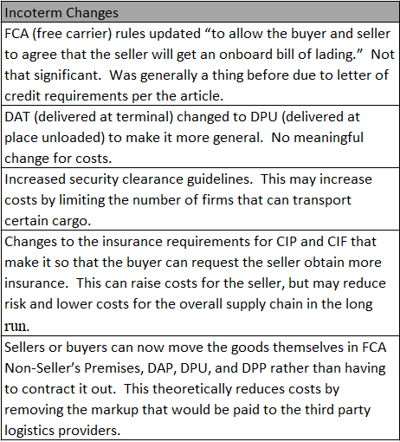

Table 1: Incoterm Changes

Recently, Incoterms 2010 underwent a few changes to become Incoterms 2020. These differences are minor and Incoterms 2010 can still be used if both buyer and seller agree (Ivetic 2020). Knowing that Incoterms do not change with the newest revision, the proposed model that is based on the rules of Incoterms 2010 can be implemented and relevant to today’s global supply chain networks. Global Supply chain research has focused on developing models to monitor and create strategies based on international factors. As seen in the following section, the current models take different aspects from economic and tax policies, but not the ones this particular paper focuses on.

*3 Models for International Tax Impacts*

Tax policy changes made by one country affect the international trade between companies. Dr. Paternina et al. modelled supply chains in Colombia based on Colombian trade policies and concluded that there are 5 sectors that benefited the most: cosmetics and toiletries, leather and leather goods, machinery and electronic equipment, construction materials, and metallurgical industry (Paternina 2018). This conclusion was done by considering values and functions that involved Free Carrier (FCA) terms, inventory stocks, inventory cycle, lead times, sales price and margins, demands, and costs. The model does not include the trade impacts of more supply chain tiers, such as customers of importers and suppliers of exporters (Paternina 2018). Therefore, there is ample space to expand the model to involve trading conditions that can determine supply chain disruptions and impacts per supply chain tiers.

Other research in tax policy has focused more on remediation tactics for companies to base their business models in. For instance, Gkikopoulos et al. focus on the effects of Section 174 in the Tax Cuts and Job Act (TCJA) in the United States of America (USA). The model implements a function on tax avoidance, firm characteristics controls, firm fixed effects, and industry fixed effects (Gkikopoulos 2021). By comparing tax avoidance and productivity, the model is capable of being applied to market circumstances such as the one found in 1997 Ireland, where two legislations, the Tax Consolidation Act and the Finance Act. Although the model does allow an insight into the research and development possibilities due to tax avoidance, it lacks the ability to be extended to other economic constructs, since the productivity variables are proxies that fail to capture implicit taxation and conforming tax avoidance (Gkikopoulos 2021).

Tax policies bring unknown challenges onto the supply chain. Vidl et al. do not focus their model in tax or other policies, but instead their model reflects management strategies, data and information, and quantitative techniques, which allows fine tuning (Vidl 2000). This type of model is adequate to provide a flexible system that can analyse uncertainties in business models, but cannot provide the analysis that is involved in this paper. Dogan et al. have a model that can be used to provide savings opportunities through applying strategic and tactical decisions (Dogan 2001). Again, the model lacks tax application since it does not take tax credit for loss and uses Net Income After Taxes (NIAT).

Since companies want to limit their tax responsibilities, models that reflect corporate tax rates are crucial, especially for international countries. Goetschalckx et al. present a model that incorporates corporate tax of 2 countries as parameters and net income before tax (Goetschalckx 1999). Moreover, the net income before tax is used as decision variables. This model covers taxes, but does not allow analysis on how the taxes disrupt profit repatriation nor does it provide location decisions (Goetschalckx 1999). Taxes limit the maximum profit, therefore other models, such as the one He et al. developed, provide a means of portraying the connection between distinct products, assembly, costs, and demand (He 2020). He et al. present a model that provides the flexibility needed to analyse continuously changing market conditions, but lacks the variables needed to involve tax disruptions to the consumer.

Incoterms are variables that can be found in some supply chain network models. For instance, Ivetic et al. developed a model that uses Incoterm clauses to measure the performance in transportation and logistics systems. The model’s results showed that incoterm clauses did not have a statistical significance, since countries only lower or increase the distances the companies will move through based on countries’ Incoterm scores, Serbia in this case (Ivetic 2020). Although Incoterms are included in the model, the model does not take into account tax profiting, sale contracts, and different transportation modes. This lack of factors limits how far the model can be applied throughout a supply chain network, which is currently set up as a transportation optimization model that acts as a restricted gravity model (Ivetic 2020). Another model that introduces the use of Incoterm policies is presented by Lim et al. This model utilises blockchain smart contracts under the Rawlsian algorithm to set real values to costs between buyers and sellers for different stages of the transportation journey (Lim 2021). The model does not consider how companies might direct themselves upon different tax environments.

Some supply chain network models, as those presented by Nechaev et al., focus on the delivery terms (E, F, D, and C) by using the transportation time and delivery costs in their functions. This model collects data on costs per export under different modes of transportation (Nechaev 2021). Being able to determine the best case modes of transportation depending on the changes or preferences under Incoterms is presented, along with the ability to aid companies in accelerating the turnover of goods flow to maximise profits based on the Incoterm rules (Nechaev 2021). Nechaev et al. developed a model that focuses on the growth of companies under a complex international network. The model presented in this paper is designed to orient on how companies will move in order to take advantage of clauses in the Incoterms.

Nickel et al. developed a model that encompasses international tax policies, transfer pricing, and Incoterms. The model takes into account exchange rates and corporate taxes in order to create an after tax profit analysis. By taking into account the use of transfer functions and no transfer functions in their model, Nickel et al. were able to prove that the transfer function is imperative to the model as a decision variable, which has the potential to bring a company 8% more after tax profit (Nickel 2019). The model could be expanded on by applying fixed costs that contain more data on a company’s employees, such as salaries and insurance, to observe their effect on the model. Nevertheless, these fixed costs do not apply to the model presented in this paper. Nickel et al. do not consider maritime transportation, which will be the transportation focus in the model presented below.

# Methods and Procedures

*Acesco Case Study:*

Through the dataset on Acesco, the model will help study the experimental setting, which includes the values of market parameters. The data used will be introduced and explained before it is fed in to a practical, empirical model. The data collected consists of various segments, such as general data consisting of sales, margin, percentage of export of sales, number of export employees, and export department salary. The next segments can be summed up in Table 2.

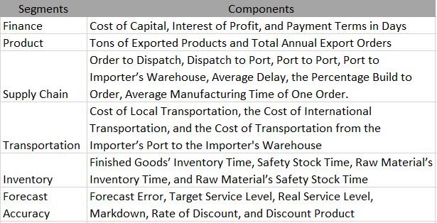

Table 2: Model Segments

The Acesco dataset has 3 overall sections: Input, Scenarios, and Results. The first section, Input, gives us the data related to the company. In our case, the company name is Acesco. The data is very selective and kept minimal, as only few details are required for calculating the results. Some metrics do have the minimum and maximum values for considering the edge cases for our model. The format of units for each of the metrics is provided in the dataset. Table 3 shows the input variables that still apply from the model Blanco et al. developed.

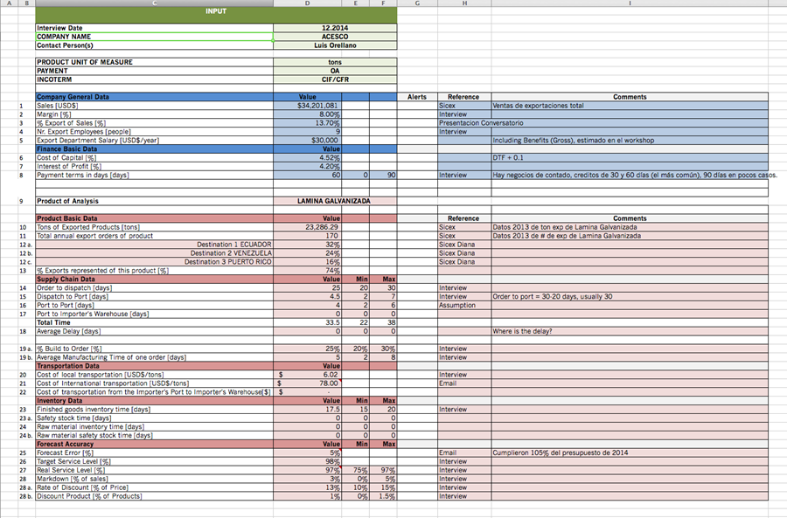

Table 3: Model Input Variables (Blanco 2015)

# Experimental Setting

Four scenarios will be considered: best case, worst case, financial case, and modification case. Apart from the total cost figures, the minimum and the maximum limits of the costs are also included. The best case gives us the optimum results of the model, as opposed to the worst case scenario in which we get the least efficient model. The financial case gives us the economic results, which are mostly observed in almost all the real time scenarios. The modifiable case can be customised and can set values for a specific variable to check the effect on the model. These scenarios will be calculated based on the baseline figures provided in the Acesco dataset. After calculating the outcomes in each scenario, observations will be made regarding the percentage breakdown of all the figures and they will be compared to whole figures for all segments. Furthermore, the performance for each segment will be calculated in order to determine the trade supply chain costs across all the scenarios that were calculated. We have made two assumptions: that a specific year will consist of 365 days and the exchange rate of COL$ per USD$ is 2100:1. The cost model consists of few scenario based values, which is prominently used to consider sensitivity based analysis on the model.

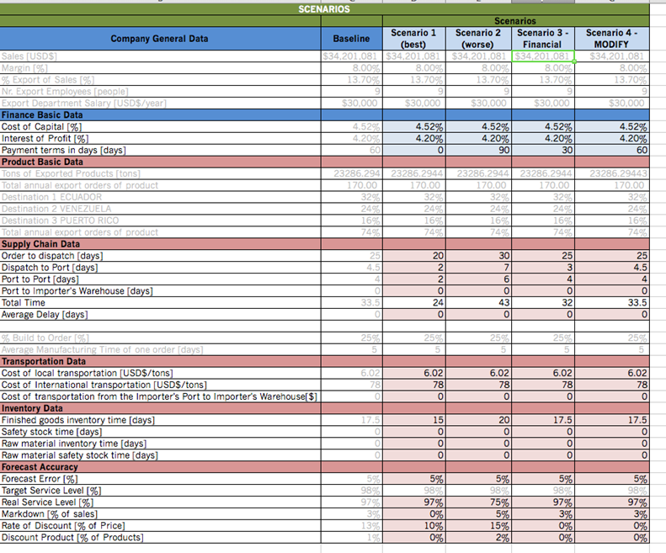

Table 4: Model Scenarios (Blanco 2015)

# Results and Discussion

*Sector Level Analysis:*

The results give us the comparative view of all the scenario based results we considered for our model.

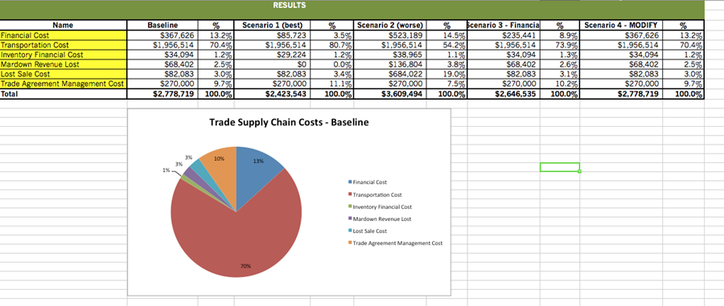

Figure 1: Model Results (Blanco 2015)

There are a total of 16 sectors in the Acesco dataset, so we will be analysing the cost based on all these sectors.

Table 5(a): Supply Chain Network Analysis

Table 5(b): Supply Chain Network Analysis

Sector level analysis gives a look at the in depth analysis that is derived from the model, as seen in Figure 2.

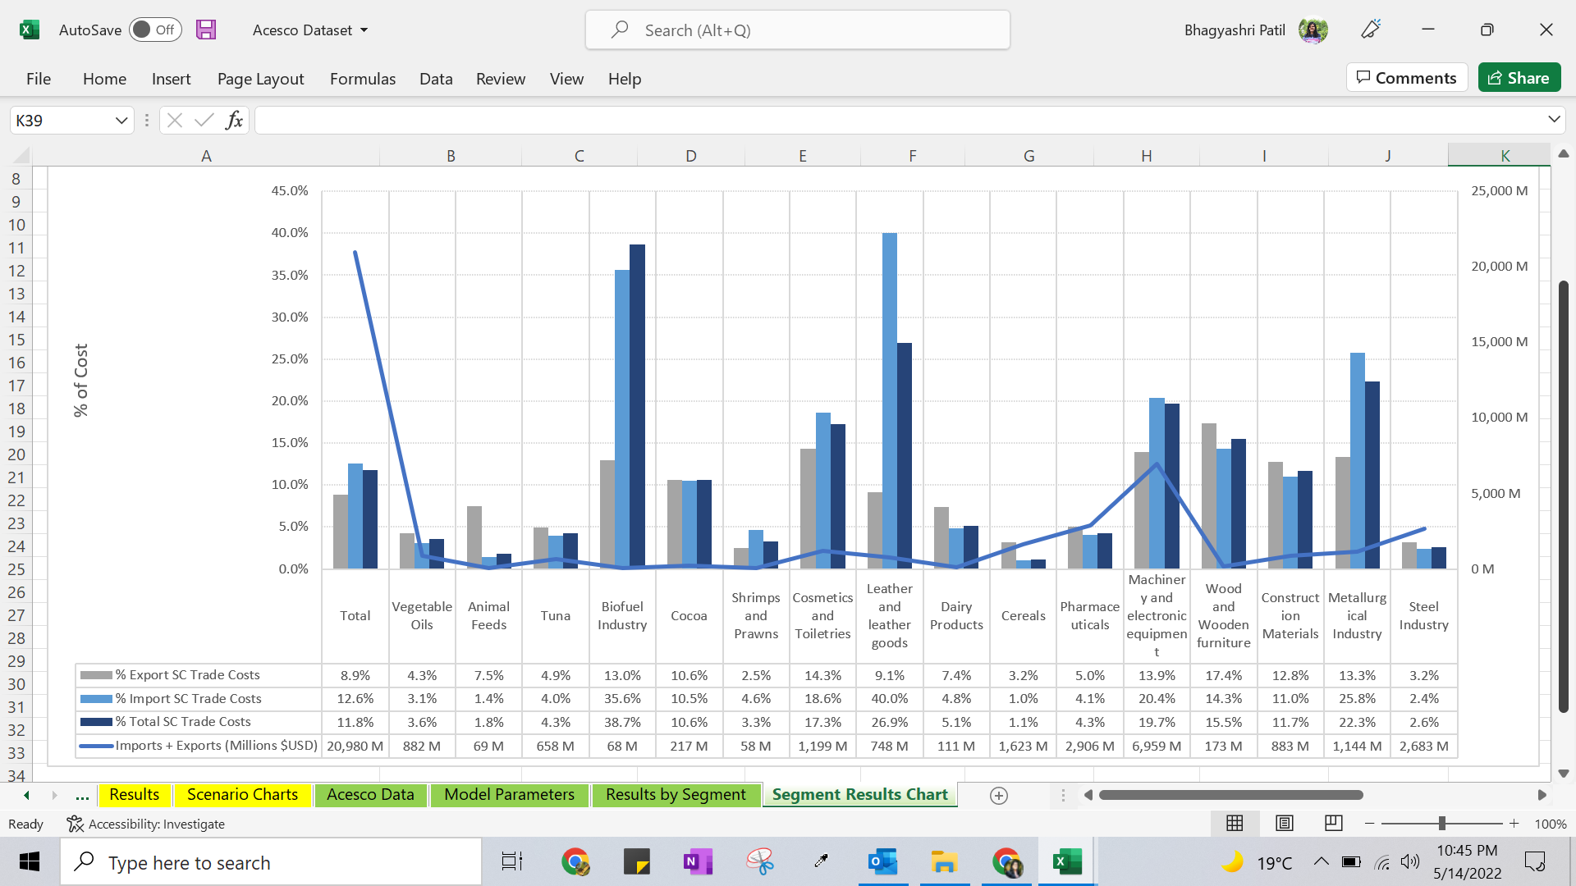

Figure 2: Sector Level Cost Analysis

Table 6 defines the values for the default parameters present in the model evaluation and the baseline values that will be used in the experimental testings. These values can be modified based on the analysis needed.

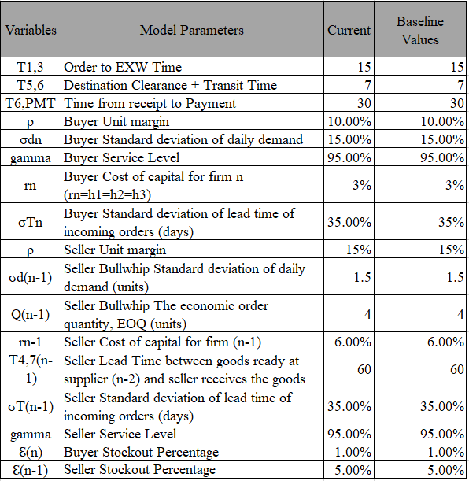

Table 6: Model Variables

Here we have modified a few of the variables from our model, as contrasted with the original model. Therefore we are able to tune to different threshold values and check for the outcome of the model. After altering these variables, we can observe that the outcome of the model as it was earlier, is tending towards the optimum solution in terms of the costs encountered for the Acesco dataset.

**Conclusion and Future Research**

We hope in this paper that we’ve illuminated some additional factors to be considered in the model. While these are highly variable depending on a given company’s circumstances, we’ve tried to lay out some items for consideration. We propose for next steps that a team try to work directly with a company to implement the ideas discussed herein and in the papers that this one was built upon. We believe that by applying the knowledge gained thus far, a company can better isolate deficiencies in its supply chain, reduce their cost, and improve their margin. Doing so would allow a more quantitative approach and validation to confirm if flags of convenience, the updates to Incoterms, or taxes are important to the model.

Another consideration is that the bulk of the research thus far has been from the perspective of the United States and Columbian economies and trade ecosystems. If future teams can work with other regions and companies within those regions, that extended work would solidify the model and introduce important regional differences that need to be taken into account when considering supply chain network analysis.

**References**

Blanco, E. Ponce-Cueto, E. and Paternina-Arboleda, C. D. Modelling The Cost of International Trade in Global Supply Chains. (2015). Cambridge, MA. Available at: <https://esd.mit.edu/WPS/2015/esd-wp-2015-05.pdf>

Lowe, D. (2020, March 5). “Incoterms 2020 vs 2010 Whats Changed”*.* Available at: *https://icc.academy/incoterms-2020-vs-2010-whats-changed/*. ICC Academy.

Hentschel, T. (2020). Incoterms 2020 - The Hidden Champions of Efficiency. The ICC Academy. Available at: <https://www2.deloitte.com/de/de/pages/consumer-business/articles/incoterms-2020-white-paper.html>

Zaiken, D. (2019). Tax Reform Impact Value Chain. Available at: <https://www.thetaxadviser.com/issues/2019/feb/tax-reform-impact-value-chain.html>

Paternina, C. (2018). Estimating the Impact of Trade Facilitation in Regional Supply Chains: A Case Study in Colombia. Available at: <https://docs.google.com/document/d/1Vf7QI4UKYRntwWrQlhoe268UuooWIkz7/edit>

Gkikopoulos, S., Lee, E. and Stathopoulos, K. (2021). Does corporate tax avoidance affect firm productivity? 2021 British Academy of Management Conference, 2021. Available at: <http://dx.doi.org/10.2139/ssrn.3856522>.

Goetschalckx, M. and Vidal, C. (2000). Modelling the effect of uncertainties on global logistic systems. Journal of Business Logistics. 21.

Dogan, K., Goetschalckx, M., and Vidal, C. (2002). Modelling and design of global logistics systems: A review of integrated strategic and tactical models and design algorithms. European Journal of Operational Research. 143. 1-18. 10.1016/S0377-2217(02)00142-X.

Goetschalckx, M. and Vidal, C.J. (1997). Strategic production-distribution models: A critical review with emphasis on global supply chain models. European Journal of Operational Research, Volume 98, Issue 1, 1997, Pages 1-18, ISSN 0377-2217, https://doi.org/10.1016/S0377-2217(97)80080-X.

Goetschalckx, M. and Vidal, C. (2001). A Global Supply Chain Model With Transfer Pricing and Transportation Cost Allocation. European Journal of Operational Research. 129. 134-158. 10.1016/S0377-2217(99)00431-2.

He, Y. and Yin, S. (2020). Cost Analysis in Global Supply Chains. Operations Research Letters, Volume 48, Issue 5, 2020, Pages 658-665, ISSN 0167-6377, <https://doi.org/10.1016/j.orl.2020.08.006>.

Chen, Z., Feng, P.,Wang, S., Zhang, D., and Zhou, X. (2022). The impact of trade policy on global supply chain network equilibrium: A new perspective of product-market chain competition, Omega, Volume 109, 2022, 102612, ISSN 0305-0483,<https://doi.org/10.1016/j.omega.2022.102612>.

Flach, L., Irlacher, M., and Unger, F. (2021). Corporate taxes and multi-product exporters: Theory and evidence from trade dynamics, Journal of International Economics, Volume 132, 2021, 103515, ISSN 0022-1996,<https://doi.org/10.1016/j.jinteco.2021.103515>.

Clausing, K. (2020). International trade policy that works for U.S. workers. Vison 2020: Evidence for a stronger economy. Available online:<https://equitablegrowth.org/international-trade-policy-that-works-for-u-s-workers/> (accessed on May 13, 2022).

York, E. (2018). The Impact of Trade and Tariffs on the United States. Available online:<https://taxfoundation.org/impact-of-tariffs-free-trade/> (accessed on May 13, 2022).

Bertalero, G., Chiara, B.D., and Rosa, A. (2020). Analysis of outsourcing conditions for freight transport and logistics among manufacturing companies: insights from a review of data and a field investigation, Transportation Research Procedia, Volume 45, 2020, Pages 459-466, ISSN 2352-1465, https://doi.org/10.1016/j.trpro.2020.03.039.

Ivetić, J. and Stojanović, D. (2020). Possibilities of using Incoterms clauses in a country logistics performance assessment and benchmarking, Transport Policy, Volume 98, 2020, Pages 217-228, ISSN 0967-070X,<https://doi.org/10.1016/j.tranpol.2020.03.012>.

Lim, A. and Pan, E. (2021). Toward a Global Social Contract for Trade - a Rawlsian approach to Blockchain Systems Design and Responsible Trade Facilitation in the New Bretton Woods era, Journal of Responsible Technology, Volume 6, 2021, 100011, ISSN 2666-6596,<https://doi.org/10.1016/j.jrt.2021.100011>.

Nechaev, A., Nechaeva, M., and Skorobogatova, Y. (2021). Toolkit for the Transportation and Logistics Infrastructure, Transportation Research Procedia, Volume 54, 2021, Pages 637-644, ISSN 2352-1465,<https://doi.org/10.1016/j.trpro.2021.02.116>.

Nechaev, A. and Schupletsov, A. (2021). Methods for Improving Efficiency of the Innovative Logistics System, Transportation Research Procedia, Volume 54, 2021, Pages 628-636, ISSN 2352-1465,<https://doi.org/10.1016/j.trpro.2021.02.115>.

Nickel, S., Razm, S., Sahebi, H., and Saidi-mehrabad, M. (2019). A global bioenergy supply network redesign through integrating transfer pricing under uncertain condition, Journal of Cleaner Production, Volume 208, 2019, Pages 1081-1095, ISSN 0959-6526,<https://doi.org/10.1016/j.jclepro.2018.10.070>.

Degnarain, N. (2020, September 20). Why isn't Panama paying its fair share of 20% of all global shipping's carbon emissions? Forbes. Retrieved May 14, 2022, from <https://www.forbes.com/sites/nishandegnarain/2020/09/20/why-isnt-panama-paying-its-fair-share-of-20-of-all-global-shippings-carbon-emissions/?sh=4736b0792a44>

William, G. (2012). Flags of Convenience: The Development of Open Registries in the Global Maritime Business and Implications for Modern Seafarers (dissertation) from <https://oceanfdn.org/sites/default/files/Gregory_georgetown.pdf>

The Procedure to Register a Ship with the Panamanian Pavillion. Consulate General of Panama Marseille. (2022, March 7). Retrieved May 14, 2022, from <https://www.consulatgeneraldepanamamarseille.com/the-flagging/procedure-to-register-a-ship/#:~:text=The%20procedure%20to%20register%20ships,of%20the%20corresponding%20fee%20done>.

The Panama Ship Registry is the largest in the world since 1993 - 22% of the world market share. Republic of Panama Ministry of External Relations. (2021, September 10). Retrieved May 14, 2022, from <https://mire.gob.pa/ministerio/the-panama-ship-registry-is-the-largest-in-the-world-since-1993-22-of-the-world-market-share/#:~:text=View%20Larger%20Image-,The%20Panama%20Ship%20Registry%20is%20the%20largest%20in%20the%20world,according%20to%20the%20Clarksons%20Research>.

Govindasamy, R. (2018, August 29). Ship registration and flag of Convenience System. DieselShip. Retrieved May 14, 2022, from <https://dieselship.com/management/ship-registration-and-flag-state-duties/>

BBC. (2014, August 5). Why So Many Shipowners Find Panama's Flag Convenient. BBC News. Retrieved May 14, 2022, from <https://www.bbc.com/news/world-latin-america-28558480#:~:text=Most%20merchant%20ships%20flying%20Panama's,to%20employ%20cheaper%20foreign%20labour>.

Clark, A. (2010, May 30). BP Oil rig registration raised in Congress over safety concerns. The Guardian. Retrieved May 14, 2022, from <https://www.theguardian.com/environment/2010/may/30/oil-spill-deepwater-horizon-marshall-islands#:~:text=In%20common%20with%2034%20other,Hawaii%20and%20Papau%20New%20Guinea>.

Maritime Administration, Comparison of U.S. and Foreign-Flag Operating Costs (n.d.). from <https://www.maritime.dot.gov/sites/marad.dot.gov/files/docs/resources/3651/comparisonofusandforeignflagoperatingcosts.pdf>

Min, H. and Zhou, G. (2002). Supply chain modeling: past, present and future, Computers & Industrial Engineering, Volume 43, Issues 1–2, 2002, Pages 231-249, ISSN 0360-8352, <https://doi.org/10.1016/S0360-8352(02)00066-9>.